# Supporting Figures

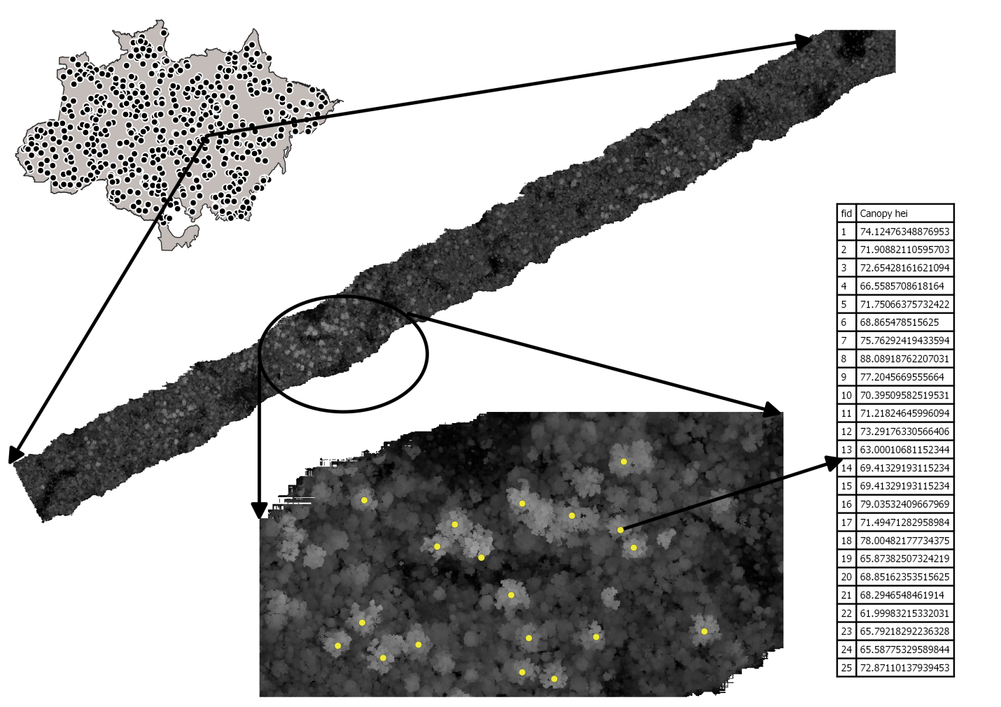

Supporting Figure 1. The uppermost vegetation heights were employed to compute a canopy height model CHM for each transects. Based on a local maximm filter, the tallest trees of each transects was located, and the tallest individual was identified and isolated to represent each transect.

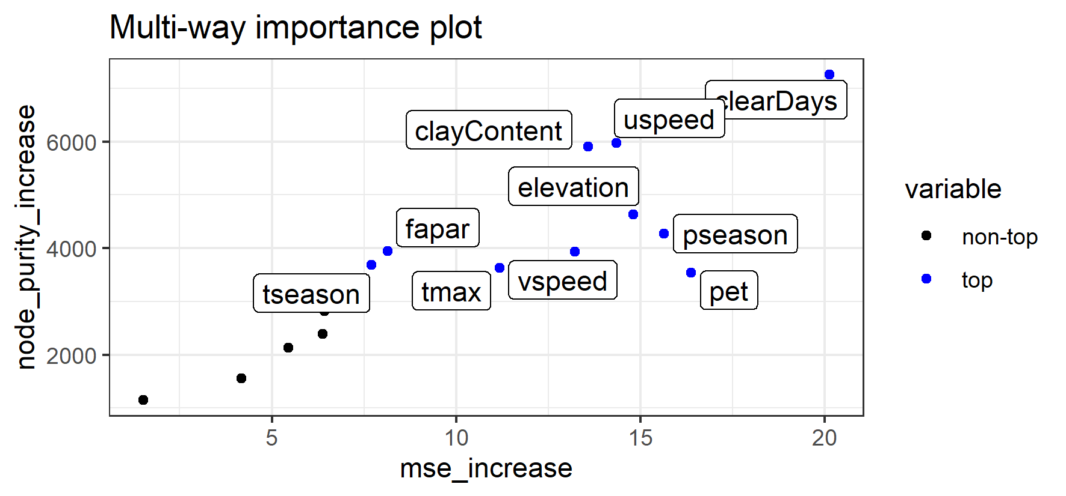

Supporting Figure 2. Variable importance considering the mean increase in accuracy (mse_increase) and the mean increase in node purity (node_purity_increase).

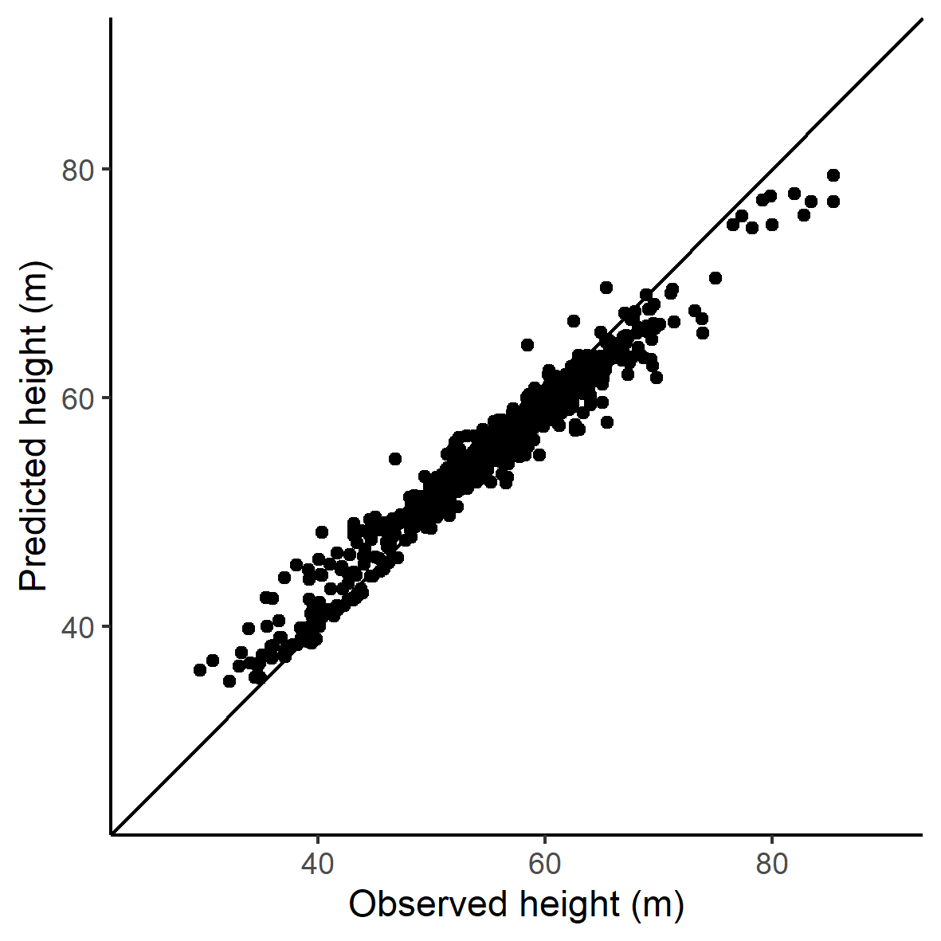

Supporting Figure 3. Observed versus predicted maximum height by the Random Forest model.

# Supporting Table

Supporting Table 1. Variable importance results for the Random Forest model adjusted considering all the transects, and removing transects located in secondary and degraded forests (i.e. intact forest).

|  |  |  |
| --- | --- | --- |
| Layer | Importance including all transects  (increase accuracy) | Importance excluding secondary and degraded forest  (increase accuracy) |
| clearDays | 25.5 | 22.5 |
| clayContent | 23.4 | 21.8 |
| topography | 23.3 | 20.9 |
| pannual | 22.4 | 21.4 |
| pseason | 21.3 | 19.3 |
| tseason | 21.3 | 19.4 |
| uspeed | 21.1 | 18.4 |
| pet | 20.2 | 17.4 |
| fapar | 20.0 | 17.3 |
| pwettest | 19.9 | 18.3 |
| tmax | 19.8 | 18.9 |
| vspeed | 18.1 | 18.4 |
| lightning | 18.0 | 17.2 |
| days20 | 16.4 | 18.9 |
| tannual | 15.6 | 15.3 |
| waterContent | 9.7 | 9.6 |